|  |
| --- |
| Group # 11 |
| Probiotics in an Oral Dosage Form |
|  |

|  |
| --- |
| Literature Review Written by Nathan LeRoy |

**Nathan LeRoy – Tablet Formation and Capsule Filling**

**Daniel Hauersperger - Drying**

**Madalyn Alm - Fermentation**

**Kiersten Troyer – Separation and Purification**

**Large Scale Manufacturing of Oral Dosage Forms – Tablets and Gelatin Capsules**

*A Literature Review for ABE 557/558 Senior Design: Production of Probiotics in an Oral Dosage Form.*

**Nathan LeRoy – Tablet and Gelatin Capsule Manufacture**

Daniel Hauersperger – Drying

Madalyn Alm – Fermentation

Kiersten Troyer – Separation and Purification

**Abstract:** Oral dosage forms are the most popular dosage form used today. Their ease of use and widespread availability has made them the form of choice for most drug products on the market. The two most well-known oral dosage forms are the compressed tablet and the gelatin capsule. Both have their advantages and disadvantages, and they both have unique ways of being manufactured. In addition, the economics and optimization of their manufacture relies heavily on the powder flowability of the specific drug formulation. The following review examines recent literature which investigates the various aspects of mass-producing both tablet and capsule oral dosage forms. As well, it investigates how various processing parameters affect the quality and output of the drug product. As stated before, both tablets and capsules have their advantages and disadvantages, but regardless of which form you use, an understanding of the process flow of your dosing unit operation is key to designing an economical and optimal process.

Introduction:

*History -* In the pharmaceutical industry, one often overlooked aspect of drugs is the dosage form of the active pharmaceutical ingredient (API). A dosage form is the physical form of a drug or active ingredient and its route of administration to the human body. The FDA classifies dosage forms as unit doses, or a drug that is administered in a non-reusable container designed to hold a quantity of drug intended for administration (other than the parenteral route) as a single dose, directly from the container (U.S. Food and Drug Administration, 2015). Common dosage forms include oral dosage forms – things like tablets, pills, or liquids. Others include intravenous injections, nasal sprays, pulmonary dosage forms, and even trans-dermal patches. There are many options, but the clear majority of API’s today are administered as an oral dosage form. About two thirds of all drugs today are given as an oral dosage form – about half of which are tablets (Manimaran, 2015). Oral dosage forms are attractive forms for their ease of use, accurate dosing, and for their stability. They have been around for over 3500 years. Only recently have pills been largely regulated and formed with more advanced techniques like compression, sugar coating, or gelatin coating (Mestel, 2002). The scope of this review will remain only on the modern formulation and forming of tablets and pill capsules.

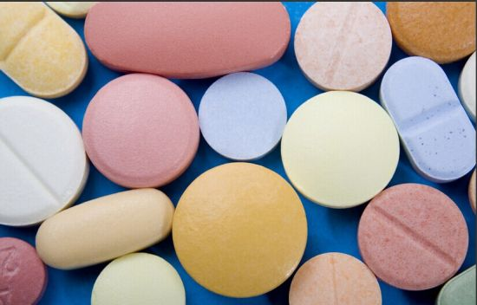*Tablets -* Tablets, in general, consist of two parts: the API and the excipients. The API is the actual drug/compound that performs the desired effect. The excipients are the inactive additives used to bulk up the product, stabilize the API, provide taste masking, or control the rate of dissolution (Katdare, 2005). Tablets are typically formed via compression. Powder flows into a die, and a press applies a significant amount pressure such that the API-excipient mixture forms a solid tablet (Fig. 1). Many times, these dies include engravings to help identify the drug product in the tablet. The tablets are ejected, and the process is repeated. To form tablets, there are many processing parameters that affect the performance and outcome including powder flowability, particle size, physical properties, and many more.

**Figure 1.** Recently pressed tablets from a tablet press.

Afterward, the tablets are frequently coated. The most well-known method is sugar-coating. However, this is not as common anymore due to the significant increase in product weight (Zhou, 2018). Tablets are more-often coated in lighter materials that increase stability or help to control the dissolution of the API from within.

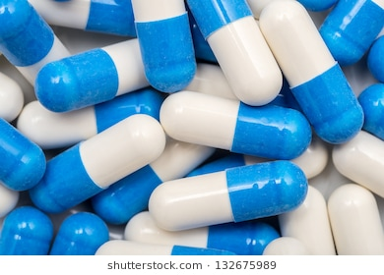*Capsules -* Capsules are typically formed by the filling of some sort of gelatin capsule and then closing that capsule. It does not require the pressure that is needed for tablet formation. However, powder flowability plays a much larger factor in the large-scale continuous manufacture of capsules. A capsule is split into two parts: the bottom and the cap. The bottom is place into a die, while the API-excipient mixture flows into the capsule. Afterwards, the top is pressed down and locked onto the bottom. The capsule is then ejected (Fig. 2). Capsules are sometimes used over tablets for API’s that have stability issues or are sensitive to moisture in the air. As well, capsules provide opportunity to formulate API’s with large particle sizes and fill them with a very accurate does.

**Figure 2**. Newly formed capsules. Notice the separate top and bottom pieces (Blue and white respectively).

Gelatin is the most common capsule material, but recently others have been formulated for vegan diets and to help enhance stability of the product.

Many times, an API or drug can be given in either a tablet form or a capsule form. Many-times antibiotics are dosed in both forms, and the specifics of the antibiotic are what dictate the final dosage form. The specific dosage form for a drug needs to consider the mechanism of action, the drugs physical properties, and the overall goal of the drug.

Methods and Factors of Tablet Formation:

*Tablet Formation Overview –* Modern day tablet formation in the pharmaceutical industry is a continuous process. The basic steps are: 1.) The feeding and die filling process, 2.) the pre-compression and roller compression process, and 3.) the tablet ejection cam process. Each step happens after the other and it happens continuously. A typical tablet press machine consists of about 20 dies and die punches fixated on a circular disk-mount. Located on adjacent sides are the compression rollers and the fill cams. The fill cams are responsible for filling the dies, the disk-mount rotates, and the tablets are compressed with the punches via the compression rollers pressing down on the top of the punches (Fig. 3) (I.C. Sinka, F. Motazedian, A.C.F. Cocks, K.G. Pit., 2008).

*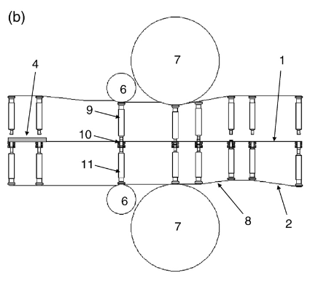Die Filling –* Powder flow is achieved using a mass flow hopper connected to a feed frame. The feed frame contains several paddles which help push the powder through. Like a fluid, the powders will flow under the presence of applied forces. Most trivially, this can be gravity. However, other known powder flow forces can be the punch removal from the bottom which creates a suction force underneath the die and “pulls” in the powder (S.Jackson, I.C.SinkaA.C.F.Cocks, 2007). One can easily see how parameters like air pressure and die size will greatly affect the flowability of the powder into the die.

**Figure 3**. The Tablet Press processing line. 1.) The filling table. 2.) 1—die table, 2—fillcam, 4—diefill area, 6—pre-compression roller, 7—main compression roller, 8—ejection cam, 9—upper punch,10—die, 11—lower punch.

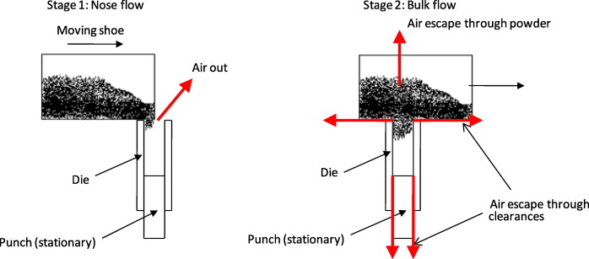The simplest mechanism can be modeled as the show-die filling mechanism (Fig. 4). An oscillating shoe moves of the die and will continuously fill the die. The powder is gravity fed into the die. At low shoe velocities, complete die filling is achieved. However, at high shoe velocities, impartially filled dies are observed.

**Figure 4.** A shoe mechanism oscillating to dispense powder into a die which is sent to subsequent compression.

The “critical velocity” is the maximum velocity at which we continue to achieve a completely filled die (Wu et. al, 2003). Experiments have been done by Sinka *et. al.* to find the critical velocities for die filling under various conditions. The following data were collected using a rectangular die having a 10×10 mm opening and 20 mm height. The shoe dimensions are 30×60 mm (Sinka, et. al, 2009).

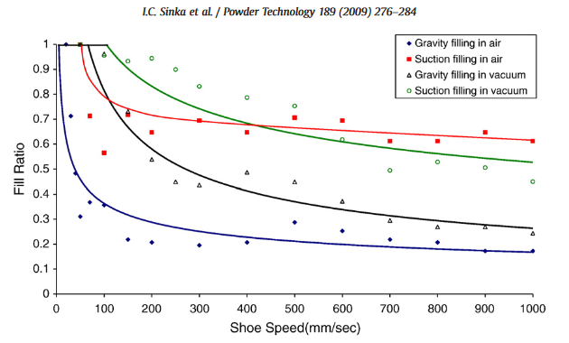One can see that there is significant improvement in the die filling when using a suction filling mechanism in a vacuum (Fig. 5). These should be considered when designing a large-scale process for tablet formation.

**Figure 5.** Data showing the fill ratio of the die at various shoe speeds for different filling techniques. The critical velocity is the max velocity that retains a fill ratio of 1.

*Compression –* Compression is key to ensure that a stable and non-friable tablet is achieved during production. The die punches are passed under two sets of rollers – a small pre-compression roller and a large main compression roller. The pre-compression roller is responsible for removing air and decreasing porosity, while the main compression roller is responsible for the bulk of the compression. As one would expect, the actual amount of compression greatly affects the quality of the tablet in the end. This is characterized via the tensile strength of the tablet in the end, which can be calculated using Hertz’s theory of elastic loading (S.P. Timoshenko, 1970).

$$σ_{t} = \frac{2P}{πDt}$$

Where P is the pressure, D is the tablet Diameter, and t is the tablet thickness. A higher tensile strength correlates to an increased tablet integrity. Compression is the main factor that increases tensile strength, however, it may not always be best to increase tablet compression pressure to as high as possible. One can imagine that an overly high tablet compression will result in cracks, lamination, and decreased porosity which reduces dissolution rate and subsequent bioavailability. Additional experiments by Sinka *et. al.* showed how an increase in pressure is directly correlated to an increase in tablet tensile strength. Various inert excipients were subject to compression between 1 and 20 MPa, and the subsequent tensile strength was measured. There existed a very strong positive correlation between roller pressure and tensile strength (Sinka *et. al.*, 2009).

It should be noted that tablet compression is not the only factor that can affects the tablet quality. Other factors like the die press (turret) speed, the die position and shape, and the feed frame speed can affect the overall integrity of the tablets. In addition, the actual tablet formulation has a great effect on the final state of our tablet and usually empirical data is required to understand how the formulation contributes to the compression profile of our tablet (Salman *et. al.*, 2007).

*Tablet Formulation –* Tablet formulation refers to the recipe of excipients that are added to the API before final dosage form formation. Excipients are often inert ingredients that have many responsibilities. One common role of excipients is bulking. Often the API is required to be administered at such a low concentration that creating a pure product to be taken wouldn’t be safe or practical. Thus, excipients are added to create a larger product which are easier to manufacture and take. Excipients are also included to help increase stability. This could be things like coatings which retain a certain water activity in the tablet, protect against photo-degradation, or even decrease the tablet friability. There are also many other excipients that can help dissolution and increase the bioavailability of the API (Zhou, 2018).

*Particle Size Prediction –* One of the most important process parameters for the formation of tablets and the flow of powder in machinery is the particle size distribution of our API. Milling is used often to decrease the particle size. A decreased size fosters better tablet integrity at equal compression parameters. The size distribution of particles can be modeled and predicted using various process parameters to help predict the behavior of powder flow in the system. This review won’t get into the specifics right now as it is extremely convoluted and requires significant computation. However, there are some obvious correlations. Impeller rotational speed of mills used to decrease the particle size has the greatest affect on the particle size distribution. Moisture content and friability affect the size, but don’t have nearly the affect that impeller speed shows. It is recommended that one fit data empirically to understand how process parameters affect the overall particle size distribution of our API. Finally, small particles typically correlate to a better tablet compressibility, but a lower powder flowability. It requires some experimentation to obtain the best process parameters for ones own individual system (Metta *et. al.*, 2018).

Methods and Factors of Capsule Filling:

*Capsule Filling Overview –* The filling of capsules is very similar to that of creating tablets. However, instead of compressing the formulation into a hard, solid tablet, it us encased into a gelatin capsule. Capsules have many benefits over tablets. Namely, the lack of a need for advanced excipients, decreased overall particle size, increased resistance to changes in humidity, and better product identification. However, since the API formulation is being encased in a hard gelatin shell, this makes the mass production of such dosage forms a little trickier. Instead of a single feed – API formulation, we know have two: API formulation powder flow and the hard gelatin capsule flow. In addition, these capsules are very specific in their size and shape, and thus they must be oriented properly to allow for filling. Once they are oriented, however, powder be dispensed into them, they can be closed, and they can be ejected and sent for subsequent processing, since this dosage form uses a hard gelatin shell, there is little need for taste masking and complex excipients to promote dissolution and product formation (Podczeck, 1999).

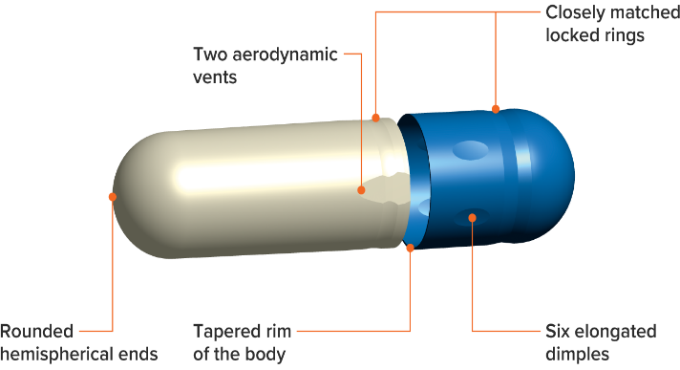*Capsule Inlet and Orientation –* The orientation of the hard gelatin capsules is of obvious concern. The bottom capsule needs to be set into the die right side up. For this reason, many manual and semi-automatic capsule filling machines exist. These require someone to manually place the capsules in the dies to be prepped for filling. Automated machines, however, use a variety of techniques including computer guidance, and special spatial filters to automatically orient the capsules properly to be prepped for filling (Fig. 6), (CapsuGel, 2013).

**Figure 6.** A diagram that shows the locking mechanism of a gelatin capsule.

*Tamping pin capsule filling –* This process utilizes a bed of powder to sequentially fill a plug which is finally ejected into the capsule body. A pin will push an amount of powder into a plug about 5 times in row, filling the dosing disc. This plug is then ejected out of the dosing disc chamber and into the bottom body of the gelatin capsule through a deflector. The deflector separates the powder bed from the built up plug, allowing it to be fully ejected. Subsequently, the top of the capsule is pushed down and locked onto the bottom section, closing off the capsule and readying it for further processing. Fig. 6 illustrates the locking mechanism of capsules. Fig. 7 below illustrates how the overall tamping process is achieved in sequential order (SaintyCo, 2017).

**Figure 7.** A tamp press diagram which creates a plug to be pushed into a gelatin capsule.

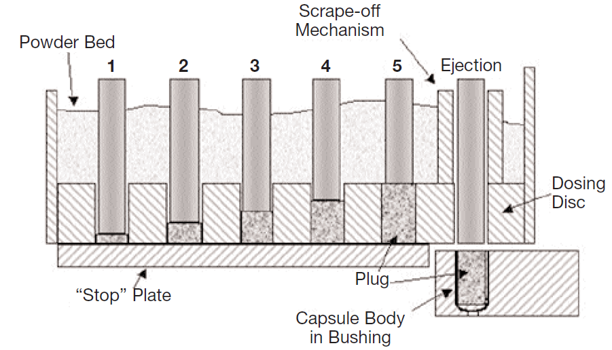Experiments have been conducted to examine the filling of hard gelatin capsules using a tamp filling machine. Podzceck *et. al.* examined the quality of tamp filling with various excipient powders and formulations. Using a Bosch Model GKF 400S Encapsulator. The researchers looked at various bulk densities of product, powder flowability, particle size distribution, and many more factors. It was found that a much larger range of formulation properties can be filled with a tamp filling machine than previously thought. To assess the consistency of fill weight, a coefficient of variation was used. This is precisely:

**Figure 8.** A dosator capsule filling mechanism. A plug is formed on the right which is then dispensed into a capsule on the left..

$$CV = \frac{σ}{μ}$$

where σ is the standard deviation of filling weight, and µ is the average filling weight (NIST, 2017).

The influence of the powder bed height on the capsule fill weight increases with decreasing flow properties. For moderately flowing formulations, the coefficient of fill weight variability seems to be largely independent of bed height and filling speed. The overall trends and patterns are very complex and further work is required to completed understand the relationships.

*Dosator Capsule Filling –* A dosator filling machine is very similar to tamp filling machine in that it repeatedly stamps a powder bed to create a slug of powder which is to then be dispensed into the capsule body. However, the dosator filling machine fills upwards by pressing down in a cookie cutter fashion rather than stamping down into a cavity. 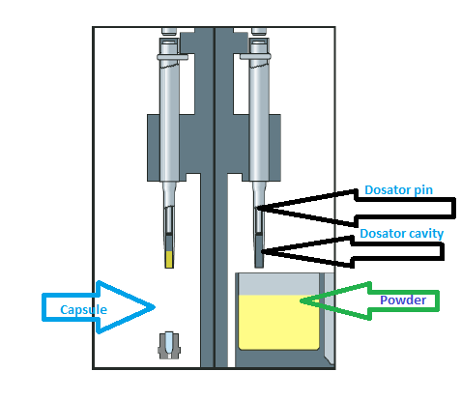

Experiments by Podczeck *et. al.* have been conducted to examine exactly the forces involved in maintaining a plug within the dosator cavity. They examined different powder formulations and applied various forces and used and mathematical equation which calculates minimum stress to be applied to a powder bed to form a stable arch, i.e. to retain the powder in a dosator nozzle can be calculated from Tan et al. (1990):

$$σ_{z req}= \frac{FFrγg}{sin 2ηϕ}$$

where FF is the Jenike flow factor. g is the acceleration due to gravity, r is the span radius, γ is the powder bulk density, and ϕ is the wall angle. This force is necessary.

It was found that, in general, higher values of wall stress are required greater compressive stress at the top of the powder bed. These stresses don’t necessarily correlate to better capsule filling. However, the best conditions for capsule filling occur when the compression setting of the mG2 simulator was set to 0 (Tan *et. al.*, 1990).

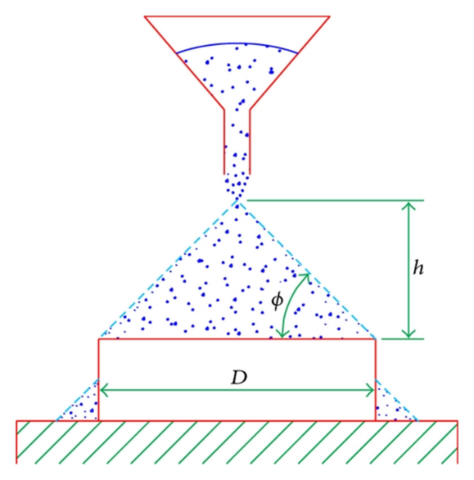Powder Flow:

*Overview –* Powder flow is extremely important in the manufacturing of drug products. Like all other mass-produced products on the market, a plethora of transport operations take place. Understanding and mathematically characterizing these transport phenomena is crucial to the design and maintenance of the systems which produce drug products.

Like liquids, powders flow under applied forces. The exact physical properties of the powder’s constituents govern the flow behavior. A “good flow” is one that provides little resistance, little clumping, and promotes low-energy transport operations. Mathematical characterizations of powder flowability include angle of repose, bulk density, tapped density, Carr’s compressibility index, or Hausner ratio (Shah *et. al.* 2007).

**Figure 9.** The mechanism by which the angle of repose is calculated.

*Angle of Repose –* The angle of repose is an extremely popular method of measuring a powders flowability. The basic idea is measuring how steep the slope of a pile of your powder is. Specifically, an amount of the powder is poured onto a circular surface. The powder continues to pour until it starts to fall off the sides. At this point, the angle of the slope of the pile is measured (Fig. 9) (Shah, 2007). One can imagine that better flowing powders will have smaller angles of repose, where stickier and poorer flowing powders will have much larger angles of repose. The angle is calculating precisely as:

$$θ = \tan^{-1}\frac{h}{r}$$

*Bulk Density –* The bulk density is a relatively trivial concept. It is the density of the powder when stored in bulk. A smaller bulk density indicates that more air is stored between the formulation particles and thus, it will flow better. However, it is not the only measure of flowability – many other physical properties contribute to flowability (SoilQuality, 2018). The formula for this is:

$$ρ_{bulk} = \frac{m_{bulk}}{{volume}_{bulk}}$$

*Tapped Density –* The tapped density is similar to the bulk density; however, it examines the density of the formulation after having been tapped in a container for an extended period of time. Imagine placing the formulation into a graduated cylinder and tapping it mechanically on a surface until little more volume change is observed. The density is then calculated again. This is important to understand as it helps to characterize how the powder’s density changes with increased flow and movement of the powder. The tapped density is identical to calculating any other density (Particle Analytical, 2017).

*Hausner Ratio –* The Hausner ratio is calculated using the same procedure where an initial volume is calculated and the graduated cylinder is tapped until little volume change is seen. The ratio of these to volumes is calculated:

$$Hausner Ratio = \frac{V_{0}}{V_{f}}$$

One can see that the range of values for this ratio is between 1 and infinity. A value of 1 indicates no volume change, while a value that tends toward infinity represents a huge change in volume. Powders that exhibit little volume change (i.e. smaller ratios) exhibit better flowability. Specifically, a Hausner ratio above 1.25 is consider to be “poor flowability” (Grey *et. al.*, 1969).

Conclusions:

Understanding the system and being able to mathematically characterize its behavior is essential to the design and creation of economical and robust processes. The production of tablets and capsules to store drug products is no exception. Oral dosage forms have a long history and understanding their production has long been studied.

Tablet formation is a process of filling a die with API-excipient formulations and compressing the die with significant pressure to create a solid non-friable unit dose. The integrity of tablets is characterized with the tensile strength of the product which can be calculated using various processing parameters. In addition, the die filling speed must be optimized as to not lose drug product, but also maximize the system output. This is known as the critical velocity and many times must be empirically derived.

Capsules offer a great alternative to tablets when stability and drug concentration issues are at hand. They offer increased resistance to humidity, can be made without the use of advanced excipient formulations, and offer better product branding and identification. Capsules pose a slightly more difficult task to mass produce due to the added stream – the gelatin capsule input stream. In addition, these capsules must be properly oriented.

Two capsule filling methods exist: Tamp filling and dosator filling. Both have their advantages and disadvantages, but they operate on the same principle – create a plug of drug product and eject this plug in the capsule. This process can be optimized by examining the powder flowability of the product and optimizing the machinery for a decreased coefficient of variability.

Powder flowability must be empirically characterized using many different measures including angle of repose, Hausner’s ratio, and the tapped and bulk densities. All give insight as to how the powder flows and how it will flow in bulk. They are all dependent on the physical properties of the powder formulation and can sometimes be difficult to predict, although some generalizations are apparent. Smaller particles tend to flow more poorly. Higher tapped densities, bulk densities, and Hausner’s ratios tend to be associated with poorer flowability.

At the end of the day, understanding one’s unit operation is essential to creating the most economical and optimized system as possible.

**References:**

Affairs, O. of R. (n.d.). Compliance Policy Guides - CPG Sec 430.100 Unit Dose Labeling for Solid and Liquid Oral Dosage Forms [WebContent]. Retrieved October 10, 2018, from https://www.fda.gov/ICECI/ComplianceManuals/CompliancePolicyGuidanceManual/ucm074377.htm

Agba Salman, Mojtaba Ghadiri, Michael Hounslow. (n.d.). Book Series: Handbook of Powder Technology. Retrieved October 11, 2018, from https://www.elsevier.com/books/book-series/handbook-of-powder-technology

Bosch Model GKF 400S Encapsulator. (n.d.). Retrieved October 11, 2018, from http://www.dmcindustries.com/View/Bosch-Model-GKF-400S-Encapsulator-2158

Bulk and Tapped Density – Particle Analytical. (n.d.). Retrieved October 12, 2018, from http://particle.dk/methods-analytical-laboratory/bulk-and-tapped-density/

Bulk Density - Measurement | Fact Sheets | soilquality.org.au. (n.d.). Retrieved October 12, 2018, from http://soilquality.org.au/factsheets/bulk-density-measurement

Capsugel. (2018, October 11). Empty Gelatin Capsules [text/html]. Retrieved October 11, 2018, from https://www.capsugel.com/product-suites/empty-gelatin-capsules

coefficient of fill weight variation - Google Search. (n.d.). Retrieved October 11, 2018

Coefficient of Variation. (n.d.). Retrieved October 11, 2018, from https://www.itl.nist.gov/div898/software/dataplot/refman2/auxillar/coefvari.htm

Grey, R., & Beddow, J. (1969). On the Hausner Ratio and its relationship to some properties of metal powders. *Powder Technology*, *2*(6), 323–326. https://doi.org/10.1016/0032-5910(69)80024-0

Jackson, S., Sinka, I. C., & Cocks, A. C. F. (2007). The effect of suction during die fill on a rotary tablet press. *European Journal of Pharmaceutics and Biopharmaceutics*, *65*(2), 253–256. https://doi.org/10.1016/j.ejpb.2006.10.008

Katdare, A., & Chaubal, M. (Eds.). (2006). *Excipient Development for Pharmaceutical, Biotechnology, and Drug Delivery Systems*. CRC Press. https://doi.org/10.1201/9781420004137

MESTEL, R. (2002, March 25). The Colorful History of Pills Can Fill Many a Tablet. *Los Angeles Times*. Retrieved from http://articles.latimes.com/2002/mar/25/health/he-booster25

Metta, N., Verstraeten, M., Ghijs, M., Kumar, A., Schafer, E., Singh, R., … Ramachandran, R. (2018). Model development and prediction of particle size distribution, density and friability of a comilling operation in a continuous pharmaceutical manufacturing process. *International Journal of Pharmaceutics*, *549*(1–2), 271–282. https://doi.org/10.1016/j.ijpharm.2018.07.056

Podczeck, F., Blackwell, S., Gold, M., & Newton, J. M. (1999). The filling of granules into hard gelatine capsules. *International Journal of Pharmaceutics*, *188*(1), 59–69. https://doi.org/10.1016/S0378-5173(99)00208-2

Podczeck, F., & Newton, J. M. (1999). Powder filling into hard gelatine capsules on a tamp filling machine. *International Journal of Pharmaceutics*, *185*(2), 237–254. https://doi.org/10.1016/S0378-5173(99)00169-6

Qi (Tony) Zhou. (2018, September). *Tablets 1*. Lecture, Purdue University. Retrieved from https://mycourses.purdue.edu/bbcswebdav/pid-11853675-dt-content-rid-87246775_1/courses/wl_56424.201910/Lecture%209_Tablet_1%281%29.pdf

Roberts, C. (1969). Fill Weight Variation Release and Control of Capsules, Tablets, and Sterile Solids. *Technometrics*, *11*(1), 161–175. https://doi.org/10.1080/00401706.1969.10490668

SaintyCo. (n.d.). Automatic Capsule Filling Machine : Fully Automatic Capsule Filler Manufacturer - SaintyCo - YouTube. Retrieved October 11, 2018, from https://www.youtube.com/watch?v=Ejh5UonHX1g

Shah, R. B., Tawakkul, M. A., & Khan, M. A. (2008). Comparative evaluation of flow for pharmaceutical powders and granules. *Aaps Pharmscitech*, *9*(1), 250–258. https://doi.org/10.1208/s12249-008-9046-8

Sinka, I. C., Motazedian, F., Cocks, A. C. F., & Pitt, K. G. (2009). The effect of processing parameters on pharmaceutical tablet properties. *Powder Technology*, *189*(2), 276–284. https://doi.org/10.1016/j.powtec.2008.04.020

S.P. Timoshenko. (19070). *Theory of Elasticity* (1st ed.). New York: McGraw-Hill.

Tamping Pin Capsule Filling machine Vs. Dosator Type Capsule Filling Machine: The Ultimate Comparison. (2017, February 3). Retrieved October 11, 2018, from https://www.saintytec.com/tamping-pin-capsule-filling-machine-vs-dosator-type-capsule-filling-machine-ultimate-comparison/

Tan, S., & Newton, J. (1990). Minimum compression stress requirements for arching and powder retention within a dosator nozzle during capsule filling. *International Journal of Pharmaceutics*, *63*(3), 275–280. https://doi.org/10.1016/0378-5173(90)90134-P

V. Manimaran. (n.d.). *Tablets, Unit III*. Lecture, Sri Ramaswamy Memorial Institute of Science and Tecnology. Retrieved from http://www.srmuniv.ac.in/sites/default/files/files/TABLETS.pdf

Wu, C. Y., Dihoru, L., & Cocks, A. C. F. (2003). The flow of powder into simple and stepped dies. *POWDER TECHNOLOGY*, *134*, 24–39.